

26-32 Gusudong-gil, Gonjiam-up, Gwangju-si, Gyeonggi-do, KOREA

경기도 광주시 곤지암읍 구수동길 26-32

TEL : (031) 761-2279/REP ·FAX : (031) 761-2170

E-mail: [impact-kim@naver.com](mailto:impact-kim@naver.com) HomPage http//:www.cj-impact.co.kr/

OPERATION MANUAL

**PRODUCT NAME : BRAKE FLUID CHANGER**

**SPECIFICATION**

|  |  |  |
| --- | --- | --- |
| **DESCRIPTION** | **ARTICLE** | **SPECIFICATION** |
| **PRODUCT NAME** | **MODEL : 330** | **BRAKE FLUID CHANGER** |
| **BRAKE FLUID CHANGER** | **POWER** | **AIR. MAX. 5 kg/㎠** |
| **STORAGE TANK** | **Max. 1.7 liter** |
| **TYPE** | **AIR & AIRLESS BLEEDER** |
| **ADAPTER** | **STANDARD ADAPTERS** |
| **INLET PRESSURE** | **CONTROLLABLE** |
| **WASTE TANK** | **PLASTIC TANK** | **20 LITER / 1 EACH in back** |
| **LENGTH OF HOSE** | **FILL ( PRESSURE SIDE )** | **5 METER** |
| **SUCTION SIDE** | **4 METER** |
| **TOOL BOX** | **ATTACHABLE** | **24 x 10 x 10 cm** |
| **WEIGHT** | **NET** | **18 kg** |
| **GROSS** | **28kg** |
| **MEASUREMENT** | **NET** | **39(W) × 54(L) × 121H) cm** |
| **BOX** | **39(W) × 54(L) × 121(H) cm** |
| **CASE COLOR** |  | **STAINLESS ORIGINAL COLOR** |

Above specifications can be changed without any notice if it is necessary to improve its quality

# BASIC PREARATION

* Add new brake fluid ( Max. 1 liter ) into storage tank
* Connect compressure air ( Required max. 5 kg/cm2 )



# OPERATION

1. Remove waste fluid as much as possible by suction function
2. Install reserve tank cap ( proper size ) and connect to machine fluid injection ( fill ) line
3. New brake fluid fill lever On for fluid pressure and Slowly increase pressure by pressure regulator upto 1 – 2 Bar

Example : Normal car is possible to work around 1 – 1.5 bar,

New ABS system, such as few German car or USA car’s pressure may require about 3.5 Bar, but try to start to set the pressure about 1 bar first

1. Lift up the car
2. Try to suction from the Nozzle on the tire side by machine’s rubber sucking tip Lever set to Suction position and Turn the nozzle's screw nut to open the nozzle hole
3. ) When waste fluid comes out to the suction hose and to waste cup, then OK

If waste is not come out, slowly regulate its pressure up until waste fluid come out

1. When appear new fluid color, then stop, then change fluid one by one
2. When finish 4 position brake line, turn pressure regulator as pressure release position .

**Remark :** This fluid change operation need to change longest distance brake first, and next if possible )

**WASTE DISCHARGE** : Side discharge lever to vertical direction and push the Discharge button until all waste out

**330 basic BRAKE ADAPTERS**

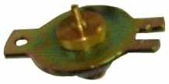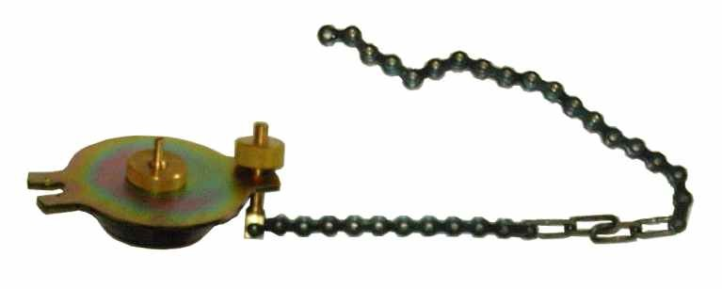

**NO 2**

**NO 1**

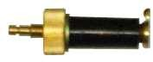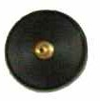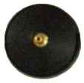

**NO 3 NO 4 NO 5 NO 6**